**DAILY ONLINE ACTIVITIES SUMMARY**

|  |  |  |  |  |  |  |  |  |
| --- | --- | --- | --- | --- | --- | --- | --- | --- |
| **Date:** | **27/05/2020** | | | | | **Name:** | **Pragathi h d** | |
| **Sem & Sec** | **8 sem B sec** | | | | | **USN:** | **4AL16CS066** | |
| **Online Test Summary** | | | | | | | | |
| **Subject** | | **IOT** | | | | | | |
| **Max. Marks** | | **30** | | **Score** | | | **28** | |
| **Certification Course Summary** | | | | | | | | |
| **Course** | **Introduction to ethical hacking** | | | | | | | |
| **Certificate Provider** | | | **Great Learning** | | **Duration** | | | **6.00hrs** |
| **Coding Challenges** | | | | | | | | |
| **Problem Statement: Micro and array update** | | | | | | | | |
| **Status: Solved** | | | | | | | | |
| **Uploaded the report in Github** | | | | | **Uploaded** | | | |
| **If yes Repository name** | | | | | **Pragathijain** | | | |
| **Uploaded the report in slack** | | | | | **yes** | | | |

Online Test Details: (Attach the snapshot and briefly write the report for the same)

Certification Course Details: (Attach the snapshot and briefly write the report for the same)

Coding Challenges Details: (Attach the snapshot and briefly write the report for the same)

Course certificate

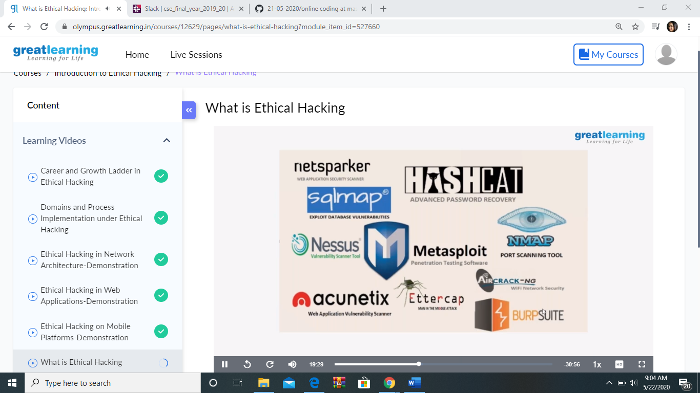

Online test

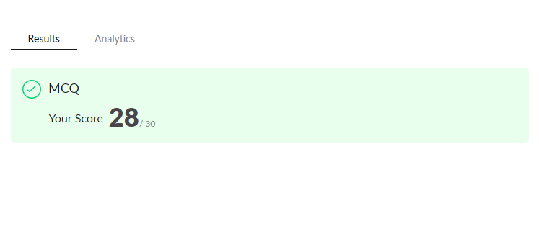

Online coding

|  |
| --- |
| import java.util.*; |
|  |  |
|  |  |
|  |  |
|  | class Main { |
|  |  |
|  | public static void main(String args[] ) throws Exception { |
|  |  |
|  |  |
|  | Scanner sc = new Scanner(System.in); |
|  |  |
|  | int t = 6; |
|  |  |
|  |  |
|  | for (int i = 0; i < t; i++) { |
|  |  |
|  | int n=6; |
|  |  |
|  | int k =8; |
|  |  |
|  | int arr[] = new int[n]; |
|  |  |
|  |  |
|  |  |
|  | for(int j=0; j<n;j++){ |
|  |  |
|  | arr[j]=sc.nextInt(); |
|  |  |
|  |  |
|  |  |
|  | } |
|  |  |
|  |  |
|  |  |
|  | int min=arr[0]; |
|  |  |
|  | for(int j=0;j<n;j++ ){ |
|  |  |
|  | if(min>arr[j]){ |
|  |  |
|  | min=arr[j]; |
|  |  |
|  | } |
|  |  |
|  | } |
|  |  |
|  |  |
|  |  |
|  | if(min<k) |
|  |  |
|  | System.out.println(k-min); |
|  |  |
|  | else |
|  |  |
|  | System.out.println(0); |
|  |  |
|  | } |
|  |  |
|  |  |
|  |  |
|  | } |
|  |  |
|  | } |